A Blueprint for Agentless Adversarial Emulation
Doc Harley
School of Business, Liberty University
Petitioning CSCN 354: Fundamentals of Distributed Systems
Dr. Phillip Schall
November 30, 2025

Introduction
The goal of this petition is to capitalize on my previous survey of both scholarship and the marketplace to lay the foundation for and start creating an agentless adversarial emulation tool. By the end of this petition, I hope to have a blueprint from which I can implement the concepts discovered in my previous work. This blueprint must include a definition of the language to be used, a definition of the required features of version one, and an outline of the logic that accounts for extensibility in the future. Alongside a blueprint, I also hope to have implementation details that match the first and second defined attack trees. The environment required to run the program will be defined as well.
Review of previous work
For background, I have provided an AI summary produced by Google Gemini 3 Pro of my previous paper “Modern Automation of Adversarial Emulation: A Closer Look at an Agentless Approach” (Harley, 2025). The full petition is available upon request.
“Recent research into adversarial emulation highlights a critical shift from manual red teaming to automated approaches, which offer the benefit of repeatable scenarios for fine-tuning incident detection and response (Bianchi et al., 2024; Bierwirth et al., 2024). However, current automated frameworks are divided into agent-based and agentless categories, both of which present significant limitations.
Agent-based tools, such as MITRE Caldera and Infection Monkey, function similarly to Command and Control (C2) frameworks. While they offer comprehensive attack chaining and lateral movement, their reliance on pre-installed agents introduces security risks and fails to simulate the "initial access" phase of an external attack (Pecoraro et al., 2021). Conversely, agentless solutions like Atomic Red Team (ART) and PurpleSharp rely on native protocols and existing administrative credentials. While these avoid the risks of agent installation, they often lack orchestration capabilities, are limited to single-host execution, or fail to simulate full kill chains without pre-existing privileges. Previous surveys conclude that a significant gap exists for a realistic, scalable, and agentless emulation tool capable of mimicking an external adversary's full attack path without reliance on prior access or native administrative protocols.”
Recent Progression
Neither scholarly research nor commercially distrubted tools have signficantly developed in the specific regard addressed by my research paper since its writing. Since I last visted this project last semester, I noticed that red canary had previously published something called atomic operator. Atomic operator is a tool written in python that is compatible with the atomic red team library and integrates with its functionality. Atomic operator shares some properties with ansible, specifically that it can execute commands over a winrm or ssh connection, without an agent on the target host.
Atomic operator is similar to what I intend to accomplish, other than a few key scope differences. The goal of this project is automation from start (reconaissance) to finish (execution), and more methods of interacting with a target than just winrm or ssh. I want my tool to be able to explore an attack tree, attempting every relevant attack and using any new information that it discovers to gain further access. We will go into attack trees and their relevance to the project later.
Blueprint

Language Selection
Since the last petition I have learned a lot of python basics from the Fundaments of Distributed Systems class at Liberty University, with Dr. Phillip Schall. This class has taught me the unique benefits of the Python programming language including its extensive library support, low development time, text processing and parsing, existing tooling using this language, and potential for future AI integrations. For all these reasons, Python is the best tool for this job and will be used for the first prototype implementation.
Definition of Required Features
The required features of the prototype, when realized in my creative honors thesis, will include an attack tree with at least two options at every layer of the simplified killchain that I developed. The program will be able to attempt two methods for reconnaissance, infiltration, and execution each based on what results are returned from initial reconnaissance. Conditional logic will define exactly how the program decides what path to take.
Logic Outline
The logic of this python program will follow the decision-making process defined by a certain attack tree, with the ability to loop back when new information abou the target system is acquired. For reference, I have provided a standard attack tree (Figure 1) that could be used for determining how to attack a given safe (Schneier, 1999). This is a clear but limited method of expressing possible attack paths on a given system.

Figure 1
Example Attack Tree – Opening a Safe
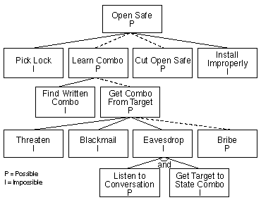
I say this is limited because it does not express the true array of possibilities found in real system, but this works well for a programmatic implementation where everything must be explicitly defined. Especially in an offensive security environment, you want to have clear, defined, and controlled attacks to avoid damaging the targets and to keep the high awareness necessary to identify gaps in visibility (alerting and response systems).
The very first attack tree that I will implement is found in Figure 2. The bare minimum that I must implement for the creative thesis is shown in Figure 3. These attacks are broken into the phases defined earlier in the definition of the required features. The modular design should allow for a simple extension of the first design into the second.

Figure 2 Figure 3
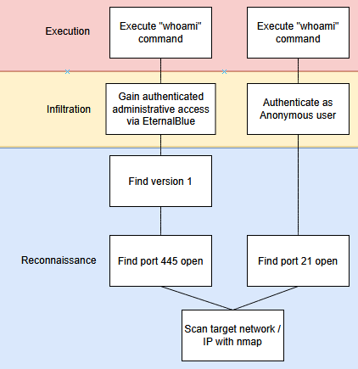
First Attack Tree to Implement Minimum Thesis Attack Tree
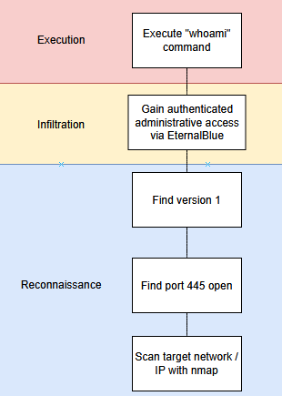
Implementation Details - Version 0
The first iteration of this system will be hosted on github at this address – https://github.com/7ermina1/A3E. This python script will use tools that come with a default Kali Linux system. The first tool is used during the scan target network/IP with nmap. This will utilize the Nmap network mapping tool to discover open ports on systems according to their designated IP addresses. The first pivotal decision point will always occur when the open ports on the host are discovered.
The infiltration step relies primarily on external tools. One tool that is very useful for this is meteasploit, and the RPC server that it comes with by default. It takes one command to locally host an RPC server and programmatically interact with this server to call specific exploits and set the options. Metasploit is required to use this version of the tool. Some things are implemented in pure python, though. The plan for the FTP interaction consists of using the ftplib library to directly interact with the server.
The variance of execution methods could eventually include running commands directly, uploading reverse shells, uploading binaries to be directly executed, installing C2 beacons, and loading programs directly into memory without storing them on the disk. The actions that any of these execution methods take could vary as well, including anything from a simple whoami to rapid sequential encryption of multiple files.
Much research went in to the decision for this method of execution, but it comes down to the fact that people have already done the legwork for much of this project, but nobody has brought all of this together with the functionality that I intend for this project. To re-implement all of these major vulnerabilities would be cool but would significantly harm development speed and likely not allow me to complete the proof of concept in a semester.
Project Use
When the proof of concept is complete, the only thing required from a user will be running the program on a Kali Linux or similarly equipped system, and providng a target IP address or range of target IP addresses. The expected response will include a report of all attempted actions and whether these actions seem to have succeeded or not.
In the future, a feature will be incorporated that allows the user to provide some credentials to be used as intelligence for the program to gain initial access. This will not be in the version produced for my thesis because it is scope-creep and does not contribute to the core mission of the application, which is to emulate the attack with no existing access whatsoever. There are many tools that emulate attacks given existing access but none that truly and fully emulate an attacker. There is a sense in which it is eventually no longer emulation but literal adversarial activity. This comes down to the intention of the attack – if the attack is piloted by the security team for the expressed purpose of refining security posture then it is not adversarial activity. However, it is concievable that someone could use this tool to gain unauthorized access into a system that they do not own.
The concern here is mitigated by the fact that none of the tools I am cobbling together are new or even difficult to use. The tool will only make that which is already quite accessible but may take a number of hours into something that can be done in a few fell keystrokes. The ethical concerns of this tool are similar to the ethical concers of a hammer (or any tool): its moral goodness depends on how it is used, all of the burden rests upon the user.
AI Extension/Integration
Considering the use of python, it will be possible to integrate this tool with the API of any AI, specifically for the purpose of MCP. In this case, it would be possible to give the AI agency over a Kali linux command-line and allow it to execute arbitrary commands via local MCP servers. An LLM would be best suited to this task, and Claude is one example of a model that has performed well in similar arenas previously (Anthropic, 2025).
For the current stage of development, this functionality will be excluded. It is also a potential issue that the AI model would be given genuine power to do irreversable damage to target systems, and the resultant indications of compromise on the host would not be clearly defined nor would they be consistent across multiple runs, as the model is far from deterministic in such a complex environment. It would be difficult to even measure all possible methods for such a system, thus making it difficult to use in a purple team scenario.
Conclusion
The groundwork has been laid by previous research to determine the gaps in research, open-source projects, and commercial projects. In this research, a feasible implementation framework has been proposed, and the model will sustain further research and development as well as make for fast development of a proof-of-concept for the thesis. Artificial Intelligence will not be implemented in the first iterations of this project but may appear in later versions if the demand is great enough. The next work produced will include a functional proof-of-concept.

References
Bianchi, F., Bassetti, E., & Spognardi, A. (2024). Scalable and automated evaluation of Blue Team Cyber Posture in cyber ranges. Proceedings of the 39th ACM/SIGAPP Symposium on Applied Computing, 1539–1541. https://doi.org/10.1145/3605098.3636154
“Claude Is Competitive with Humans in (Some) Cyber Competitions.” Cyber Competitions \ Red.Anthropic.Com. Accessed December 11, 2025. https://red.anthropic.com/2025/cyber-competitions/.
Harley, Doc. (2025). Modern Automation of Adversarial Emulation: A Closer Look at an Agentless Approach.
Pecoraro, G., D’Amico, M., & Romano, S. P. (2021). RedHerd: Offensive Cyberspace Operations as a Service. Signals, 2(4), 619–636. https://doi.org/10.3390/signals2040038
Schneier, Bruce. (1999). Attack Trees. Dr. Dobbs Journal. https://www.schneier.com/academic/archives/1999/12/attack_trees.html#rf1

